May 7, 2016

*Weather Permitting/No Rainout Dates

10:00 to 1:00 pm

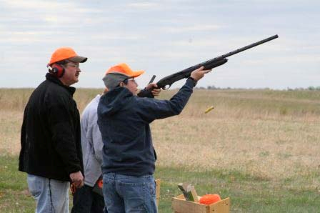
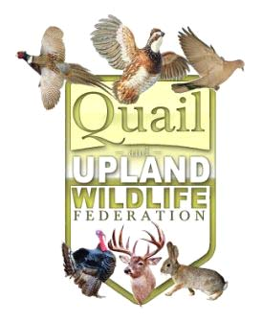
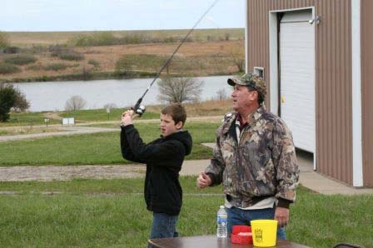
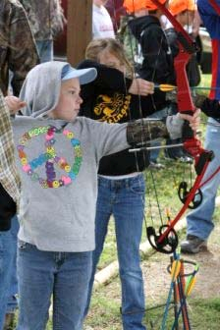
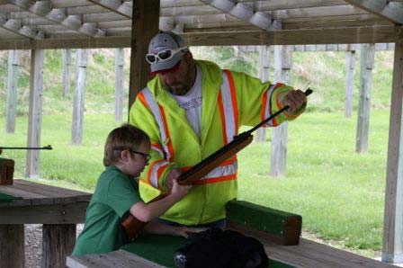


We will have lots of activities for the kids. There will be a clay shooting range, bow and arrow target shooting, and a rifle target range. We will pro- vide all of the guns, shells , and other equipment you will need including ex- pert instructions. Just show up ready to learn and have a good time. Space is limited, reserve your spot today.

All entry fees includes all the above activities as well as lunch, a small gift and a chance to win your very own youth shotgun.

RSVP to Tony Konrade at 785-220-3342 or Brian Yingling at 785-221-2141.

Lunch Included
Come Join Us...
9th Annual Kaw Valley Quail & Upland Wildlife Federation Youth Shoot
A Fun Filled Day in the
Great Outdoors

Cost per individual is $6.00
•May 7, 2016
•10:00—1:00 pm
•Shawnee County State Lake
Hunter Safety
•Ages 8-16
•Beginners Encouraged to Attend
•Limited to the first 75 entrants

